# Concept 1 – Mechanic Workshop

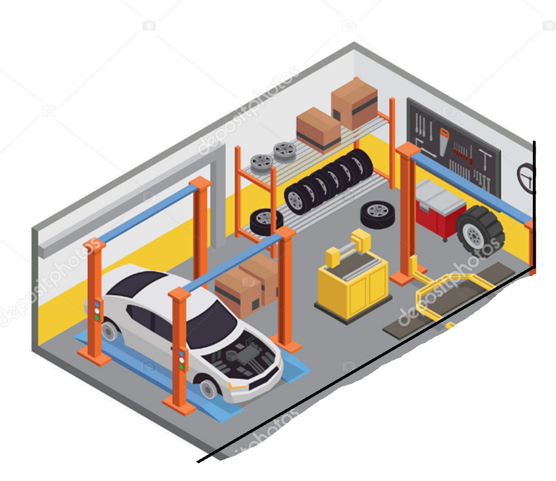

## The main inspiration image

My basic idea is a workshop like the one above. I would not be modelling the wall of wheels, but would replace it with another tool wall rack.

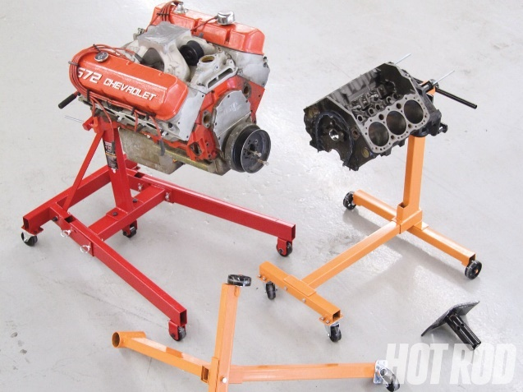

Except the yellow box in the middle of the main image would be replaced by an engine stand with an engine mounted to it. I would be happy with either the left stand with a full engine, or the right stand with a dismantled engine

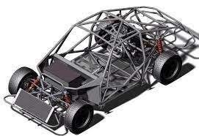 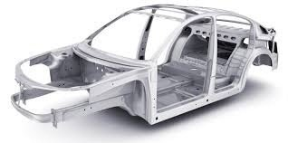

The car I want to make as maybe a chassis to show that the car is being worked on.   
I think making some of the chassis show rust and some of it clean metal that has been sanded back will show the story of someone who is slowly restoring the car.  
either chassis above I would be happy with making

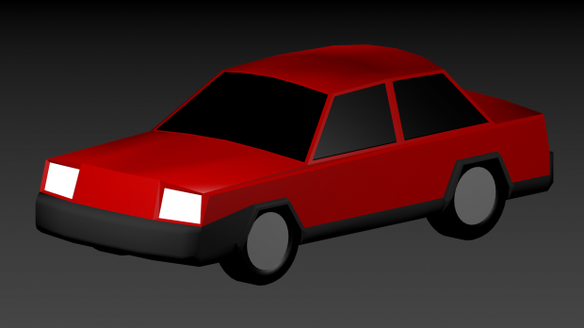

If the chassis will take too long to make, I would be happy making a car like this with the hood up and engine bay empty. If that is the case I would still want to do something with rust to show work happening.

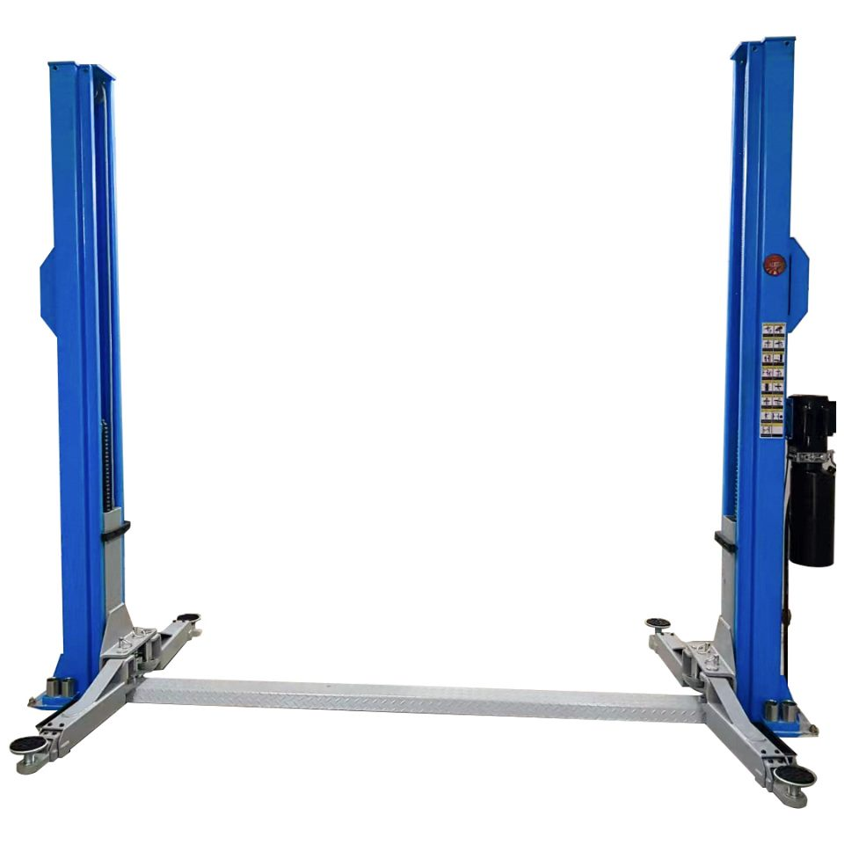 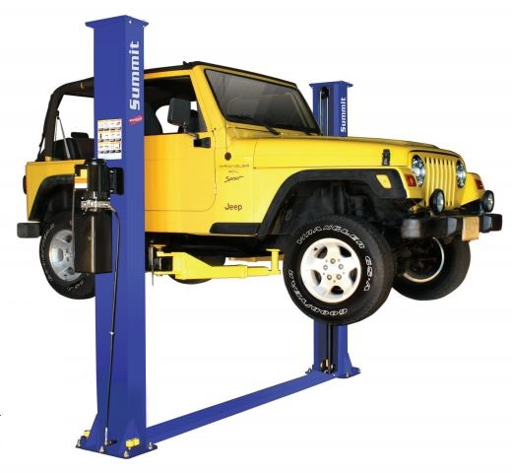

I would like the car to be sitting in a hoist like the main image. I don’t know now if I want the hoist to be raised or lowered. If the car is on the ground, it would either need wheels or to be sitting on jack stands. Car in the air could easily have wheels or not.

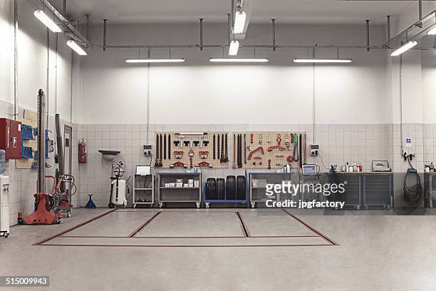 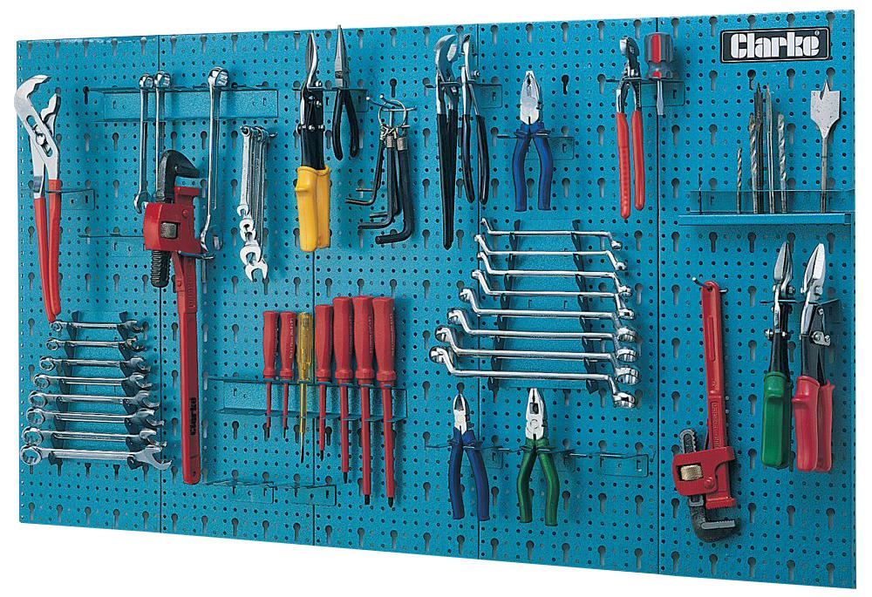

I want to have tools all over the workshop. Mostly on the walls in racks like these, but I do want some to be on/in the car and on/around the engine stand.

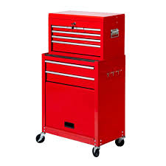 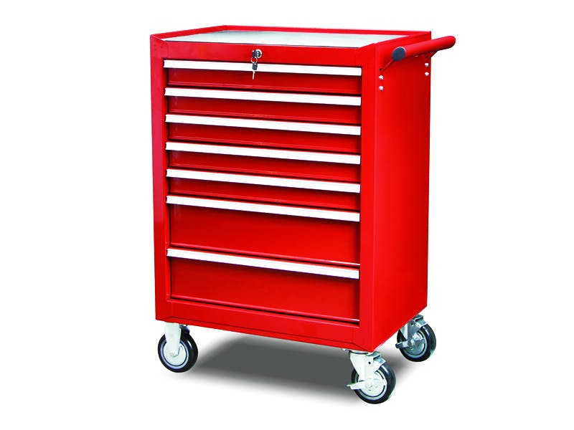

I also want to have 1 or 2 rolling tool boxes sitting near work areas. These would have a couple tools on top. Draws could be ajar but not enough to actually see in as I do not want to model open draws with tools. I feel it would be too much work

# Concept 2 – post morning kitchen rush (aka my backup)

## My main inspiration

Is honestly the rush I have every morning getting to school.   
I have enough time to get ready and that’s it. Dishes are left in the sink, bed not made, clothes everywhere from trying to find one specific item.

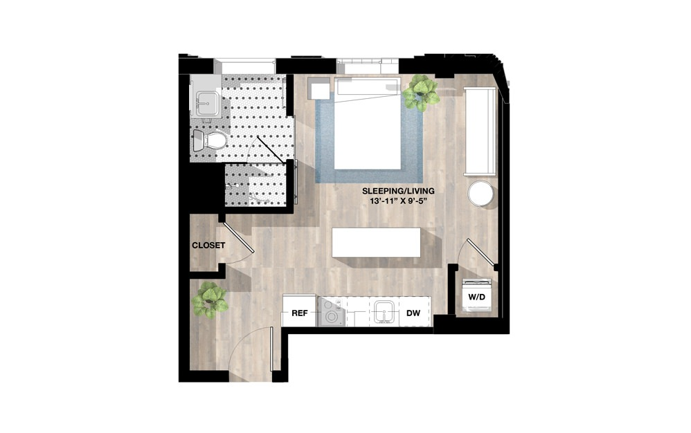

I think the easiest way to show all the chaos would be to show all the rooms that have that effect, all at once. I think a studio apartment would be great to show the mess that even one person could make each morning.

The room would be very minimalist and only the essentials would be present.   
I don’t think I want to include the bathroom, but I would imply they had a morning shower with a wet towel and hair dryer on the floor.



These are just images I used to spark ideas of what could go on the kitchen table/bench